949225007

<http://www.zgfsws.com/EN/volumn/current.shtml>

Go to the website using the URL.

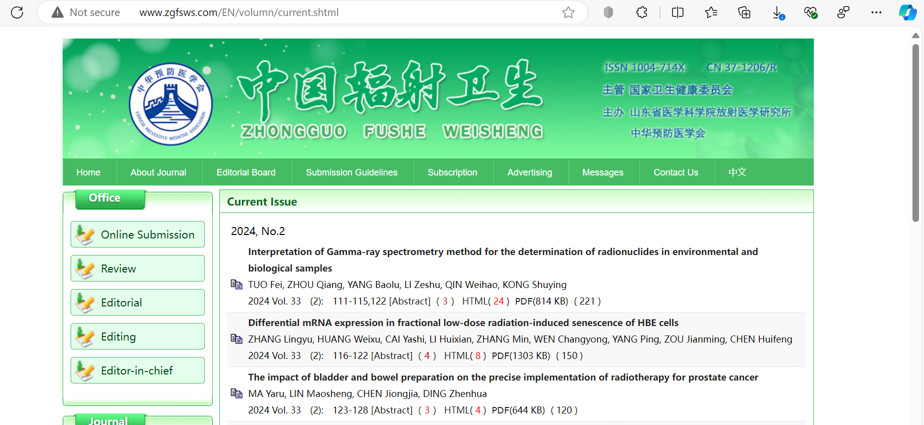

Capture article title and click

Click pdf download

Capture page range

Capture volume

Capture issue

Capture year

You will get article page like below.

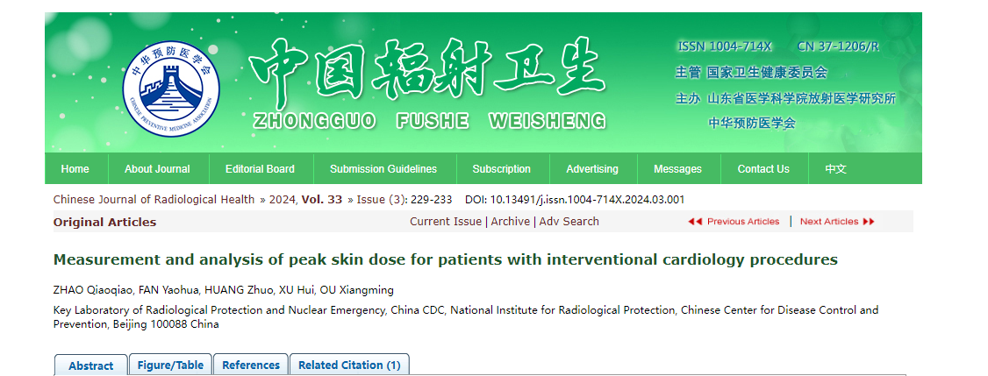

Capture doi

* In here both English and Chinese toc needs to be captured so choose language option from website language conversion .